[1.5,0.3,1]

1 run...

Downloading: 100%

411/411 [00:00<00:00, 14.6kB/s]

Downloading: 100%

263M/263M [00:06<00:00, 32.3MB/s]

training 1 epoch...

71.87570691108704 seconds used......

1 training finished! average train loss: 1.0149954986714183

evaluating...

Confusion matrix, without normalization

[[124 0 0]

[164 0 0]

[865 0 0]]

Normalized confusion matrix

[[1. 0. 0.]

[1. 0. 0.]

[1. 0. 0.]]

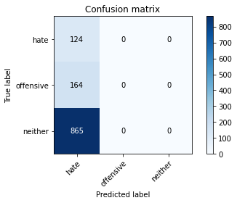

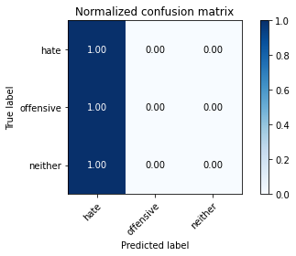

/opt/conda/lib/python3.7/site-packages/sklearn/metrics/_classification.py:1245: UndefinedMetricWarning: Precision and F-score are ill-defined and being set to 0.0 in labels with no predicted samples. Use `zero_division` parameter to control this behavior.

_warn_prf(average, modifier, msg_start, len(result))

/opt/conda/lib/python3.7/site-packages/sklearn/metrics/_classification.py:1245: UndefinedMetricWarning: Precision and F-score are ill-defined and being set to 0.0 in labels with no predicted samples. Use `zero_division` parameter to control this behavior.

_warn_prf(average, modifier, msg_start, len(result))

/opt/conda/lib/python3.7/site-packages/sklearn/metrics/_classification.py:1245: UndefinedMetricWarning: Precision and F-score are ill-defined and being set to 0.0 in labels with no predicted samples. Use `zero_division` parameter to control this behavior.

_warn_prf(average, modifier, msg_start, len(result))

precision recall f1-score support

hate 0.11 1.00 0.19 124

offensive 0.00 0.00 0.00 164

neither 0.00 0.00 0.00 865

accuracy 0.11 1153

macro avg 0.04 0.33 0.06 1153

weighted avg 0.01 0.11 0.02 1153

average eval_loss: 0.9551262321143315, accuracy: 0.10754553339115351

training 2 epoch...

71.08473658561707 seconds used......

2 training finished! average train loss: 0.9696706703730992

evaluating...

Confusion matrix, without normalization

[[ 0 0 124]

[ 0 0 164]

[ 0 0 865]]

Normalized confusion matrix

[[0. 0. 1.]

[0. 0. 1.]

[0. 0. 1.]]

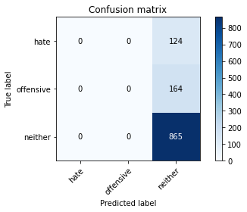

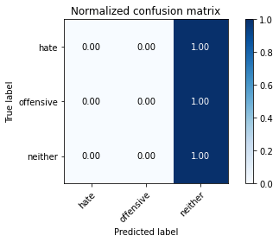

/opt/conda/lib/python3.7/site-packages/sklearn/metrics/_classification.py:1245: UndefinedMetricWarning: Precision and F-score are ill-defined and being set to 0.0 in labels with no predicted samples. Use `zero_division` parameter to control this behavior.

_warn_prf(average, modifier, msg_start, len(result))

/opt/conda/lib/python3.7/site-packages/sklearn/metrics/_classification.py:1245: UndefinedMetricWarning: Precision and F-score are ill-defined and being set to 0.0 in labels with no predicted samples. Use `zero_division` parameter to control this behavior.

_warn_prf(average, modifier, msg_start, len(result))

/opt/conda/lib/python3.7/site-packages/sklearn/metrics/_classification.py:1245: UndefinedMetricWarning: Precision and F-score are ill-defined and being set to 0.0 in labels with no predicted samples. Use `zero_division` parameter to control this behavior.

_warn_prf(average, modifier, msg_start, len(result))

precision recall f1-score support

hate 0.00 0.00 0.00 124

offensive 0.00 0.00 0.00 164

neither 0.75 1.00 0.86 865

accuracy 0.75 1153

macro avg 0.25 0.33 0.29 1153

weighted avg 0.56 0.75 0.64 1153

average eval_loss: 0.8620632599140036, accuracy: 0.7502168256721596

training 3 epoch...

71.07775545120239 seconds used......

3 training finished! average train loss: 0.9591892194889841

evaluating...

Confusion matrix, without normalization

[[124 0 0]

[164 0 0]

[865 0 0]]

Normalized confusion matrix

[[1. 0. 0.]

[1. 0. 0.]

[1. 0. 0.]]





/opt/conda/lib/python3.7/site-packages/sklearn/metrics/_classification.py:1245: UndefinedMetricWarning: Precision and F-score are ill-defined and being set to 0.0 in labels with no predicted samples. Use `zero_division` parameter to control this behavior.

_warn_prf(average, modifier, msg_start, len(result))

/opt/conda/lib/python3.7/site-packages/sklearn/metrics/_classification.py:1245: UndefinedMetricWarning: Precision and F-score are ill-defined and being set to 0.0 in labels with no predicted samples. Use `zero_division` parameter to control this behavior.

_warn_prf(average, modifier, msg_start, len(result))

/opt/conda/lib/python3.7/site-packages/sklearn/metrics/_classification.py:1245: UndefinedMetricWarning: Precision and F-score are ill-defined and being set to 0.0 in labels with no predicted samples. Use `zero_division` parameter to control this behavior.

_warn_prf(average, modifier, msg_start, len(result))

precision recall f1-score support

hate 0.11 1.00 0.19 124

offensive 0.00 0.00 0.00 164

neither 0.00 0.00 0.00 865

accuracy 0.11 1153

macro avg 0.04 0.33 0.06 1153

weighted avg 0.01 0.11 0.02 1153

average eval_loss: 1.1163952247849827, accuracy: 0.10754553339115351

training 4 epoch...